SEED MASS data as covariate to explain bWP and GDD relationship and models

**Data available:**

10 individual seeds weight per subpopulation

2 storage treatments (fresh seeds vs after ripened seeds)

18 subpopulations (12 in fresh and 12 in after ripened)

GDD values per each subpopulation

**Seed mass data exploration**

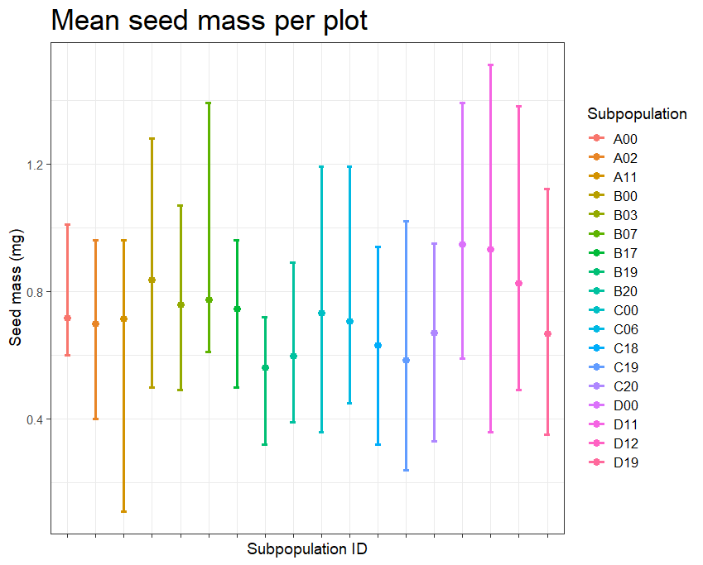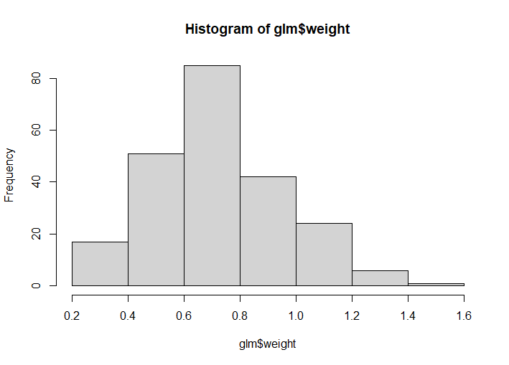

N= 226 (>180 bc repeated subpopulations in different storage treatments). Min = 0.24, Max= 1.51, mean = 0.73, sd = 0.237

**1. Check if seed mass differs between storage treatments**

a <- glmmTMB(weight ~ storage_treatment + (1|Site), family = Gamma(link="log"), data= glm) #Gamma(link="log")// gaussian

summary(a)# not significant differences in seed mass between storage treatments

Estimate Std. Error z value Pr(>|z|)

(Intercept) -0.3100402 0.0475838 -6.516 7.24e-11 ***

storage_treatmentFresh_seeds 0.0008259 0.0436529 0.019 0.985

residuals <- simulateResiduals (a) ; plot(residuals)#gaussian family NOT mets assumptions

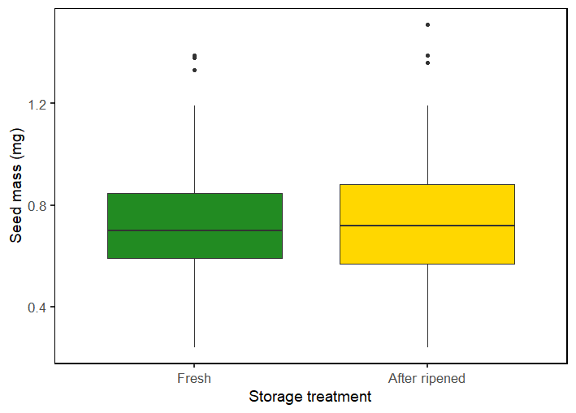

**2. Check if seed mass differs across GDD**

a <- lm(weight ~ GDD , data= glm)

summary(a)# significant relationship with GDD

(Heavier seeds in subpopulations with higher GDD)

Estimate Std. Error t value Pr(>|t|)

(Intercept) 4.599e-01 1.098e-01 4.188 4.04e-05 ***

GDD 1.430e-04 5.689e-05 2.513 0.0127 *

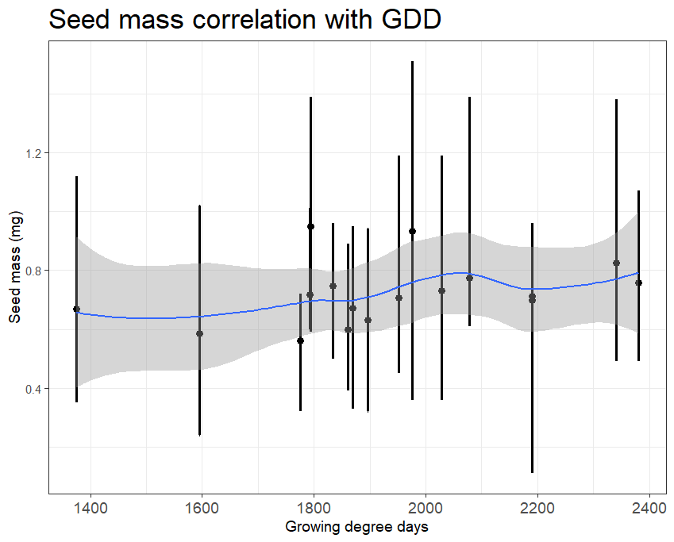

**3. Check if base water potential differs according only to weight**

a <- glmmTMB(abs(psib50) ~ weight + (1|Site), family = Gamma(link="log"), data= glm) #Gamma(link="log")// gaussian

summary(a)# not significant seed mass effect on bWP (psib50)

Estimate Std. Error z value Pr(>|z|)

(Intercept) -1.32050 0.42618 -3.098 0.00195 **

weight 0.08662 0.55204 0.157 0.87531

residuals <- simulateResiduals (a) ; plot(residuals)#gaussian family DO not mets assumptions

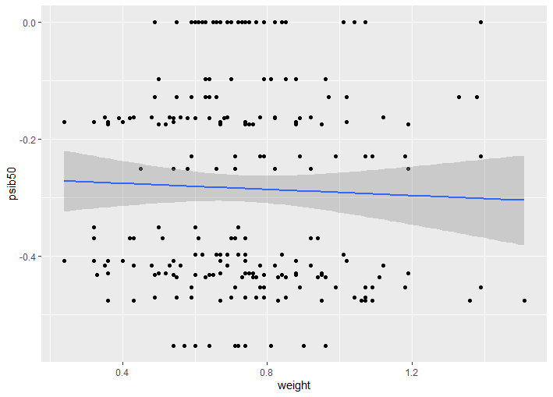

**4. Check if base water potential differs according to weight and storage treatment**

a <- glmmTMB(abs(psib50) ~ weight * storage_treatment + (1|Site), family = Gamma(link="log"), data= glm) #Gamma(link="log")// gaussian

summary(a)# not significant effect of seed mass (weight) and neither a significant interaction term

Estimate Std. Error z value Pr(>|z|)

(Intercept) -0.9153 0.5857 -1.563 0.118

weight 0.1140 0.7591 0.150 0.881

storage_treatmentFresh_seeds -1.1442 0.8166 -1.401 0.161

weight:storage_treatmentFresh_seeds-0.1368 1.0559 -0.130 0.897

residuals <- simulateResiduals (a) ; plot(residuals)#gaussian family DO not mets assumptions

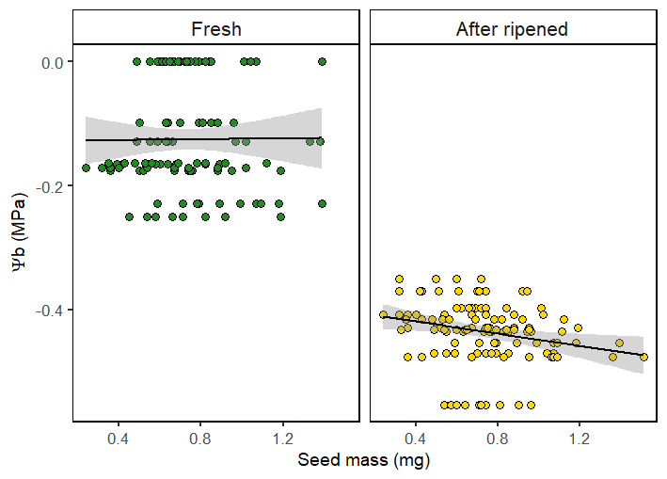

Still not significant when considering only subpopulations in both treatments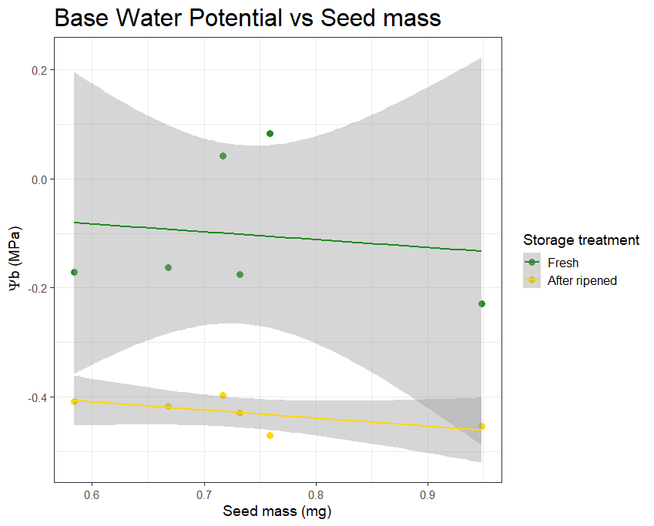

**5. Check if base water potential differ according to weight and GDD**

# problem 1 bWP and 1 GDD but 10 seeds weights careful!! some warnings appear

# problem with 0s in glmmtmb with gamma family

a <- glmmTMB(abs(psib50) ~ weight * GDD + (1|Site), family = Gamma(link="log"), data= glm) #Gamma(link="log")// gaussian

Warning messages:

1: In (function (start, objective, gradient = NULL, hessian = NULL, : NA/NaN function evaluation

2: In (function (start, objective, gradient = NULL, hessian = NULL, : NA/NaN function evaluation

summary(a)# not significant seed mass effect across both storage treatments

Estimate Std. Error z value Pr(>|z|)

(Intercept) -1.5289233 3.1345544 -0.488 0.626

weight 0.5509179 4.2602241 0.129 0.897

GDD 0.0001094 0.0016755 0.065 0.948

weight:GDD -0.0002418 0.0022498 -0.108 0.914

residuals <- simulateResiduals (a) ; plot(residuals)#gaussian family DO not mets assumptions

**6. Check if base water potential differ according to weight and GDD and storage treatment**

**# problem with 0s in glmmtmb with gamma family**

a <- glmmTMB(abs(psib50) ~ weight * GDD *storage_treatment + (1|Site), family = Gamma(link="log"), data= glm) #Gamma(link="log")// gaussian

summary(a)# not significant seed mass effect across both storage treatments

Estimate Std. Error z value Pr(>|z|)

(Intercept) -1.549e+00 4.398e+00 -0.352 0.725

weight -5.245e-02 5.931e+00 -0.009 0.993

GDD 3.539e-04 2.368e-03 0.149 0.881

storage_treatmentFresh_seeds 1.060e+00 5.926e+00 0.179 0.858

weight:GDD 4.787e-05 3.148e-03 0.015 0.988

weight:storage_treatmentFresh_seeds 9.132e-01 7.845e+00 0.116 0.907

GDD:storage_treatmentFresh_seeds -1.268e-03 3.137e-03 -0.404 0.686

weight:GDD:storage_treatmentFresh_seeds-4.356e-044.094e-03 -0.1060.915

residuals <- simulateResiduals (a) ; plot(residuals)#gaussian family DO not mets assumptions

SEED MASS AS COVARIATE IN FINAL GERMINATION RESULTS

**# 1 check if germination differ according only to weight**

a <- glmmTMB(cbind(germinated, viable - germinated) ~ mean + (1|Site/ID), family = binomial, data= final_germ)

summary(a)# not significant seed mass effect on germination

Estimate Std. Error z value Pr(>|z|)

(Intercept) -0.4337 0.8695 -0.499 0.618

mean -0.4135 1.1546 -0.358 0.720

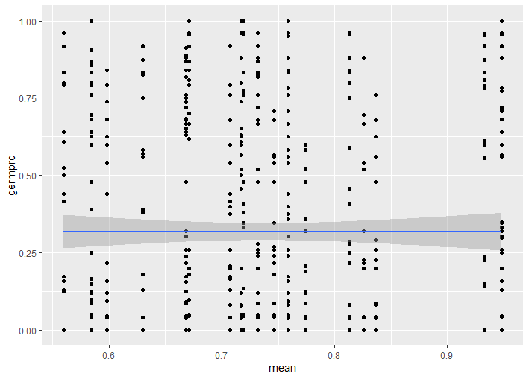

**# 2 check if germination differ according to weight AND storage treatment**

a <- glmmTMB(cbind(germinated, viable - germinated) ~ mean*storage_treatment + (1|Site/ID), family = binomial, data= final_germ)

summary(a)# not significant seed mass effect on germination and not interacting, only fresh seeds = lower germination

Estimate Std. Error z value Pr(>|z|)

(Intercept) -0.3371 0.2931 -1.150 0.25007

mean 0.2544 0.3938 0.646 0.51834

storage_treatmentFresh_seeds -0.9645 0.3252 -2.966 0.00302 **

mean:storage_treatmentFresh_seeds -0.3141 0.4339 -0.724 0.46914

residuals <- simulateResiduals (a) ; plot(residuals)

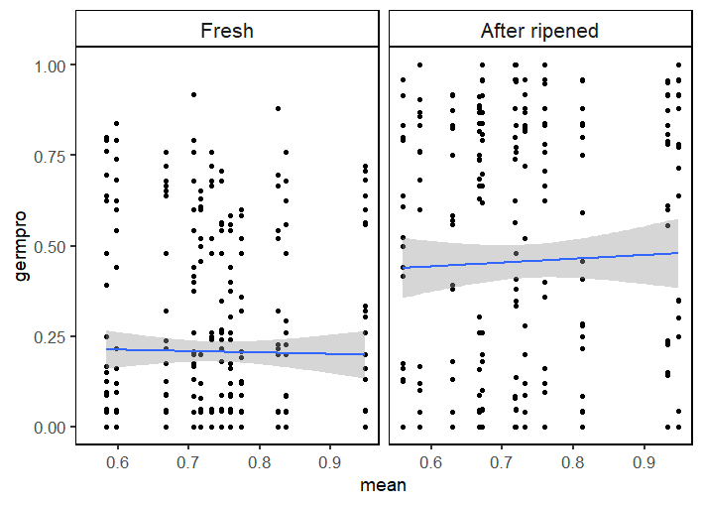

**# 3 check if germination differs according to weight, storage treatment and WP**

a <- glmmTMB(cbind(germinated, viable - germinated) ~ mean*storage_treatment*WP_treatment + (1|Site/ID), family = binomial, data= final_germ)

summary(a)# significant effect of seed mass, complex interactions check with Eduardo

Estimate Std. Error z value Pr(>|z|)

(Intercept) 1.5336 0.7282 2.106 0.03521 *

mean 2.2403 0.9919 2.259 0.02391 *

storage_treatmentFresh_seeds -0.1228 0.7610 -0.161 0.87176

WP_treatment 5.9002 1.1493 5.134 2.84e-07 ***

mean:storage_treatmentFresh -3.0255 1.0333 -2.928 0.00341 **

mean:WP_treatment 2.0550 1.5642 1.314 0.18892

storage_treatmentFresh:WP_treatment 1.7027 1.5821 1.076 0.28183

mean:storage_Fresh:WP_treatment -4.8087 2.1240 -2.264 0.02357 *

residuals <- simulateResiduals (a) ; plot(residuals)

